**Problem Statement**

Alice and Bob are playing a game on a sequence a1,a2,...,an of length n. They move in turns and Alice moves first.

In the turn of each player, he or she should select an integer and remove it from the sequence. The game ends when there is no integer left in the sequence.

Alice wins if the sum of her selected integers is even; otherwise, Bob wins.

Your task is to determine who will win the game, if both players play optimally.

**Computational Thinking on problem Statement:**

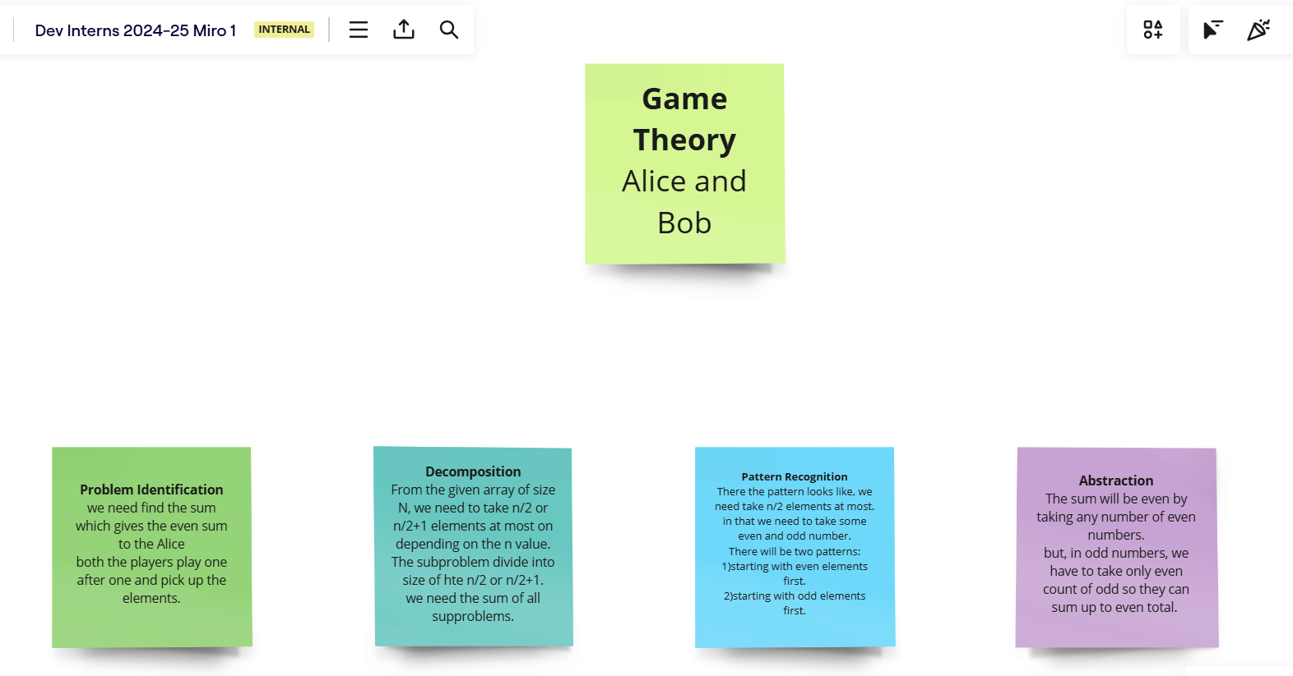

Step involved in the Computational thinking are

1. Problem Identification
2. Decomposition
3. Pattern Recognition
4. Abstraction

**Algorithm:**

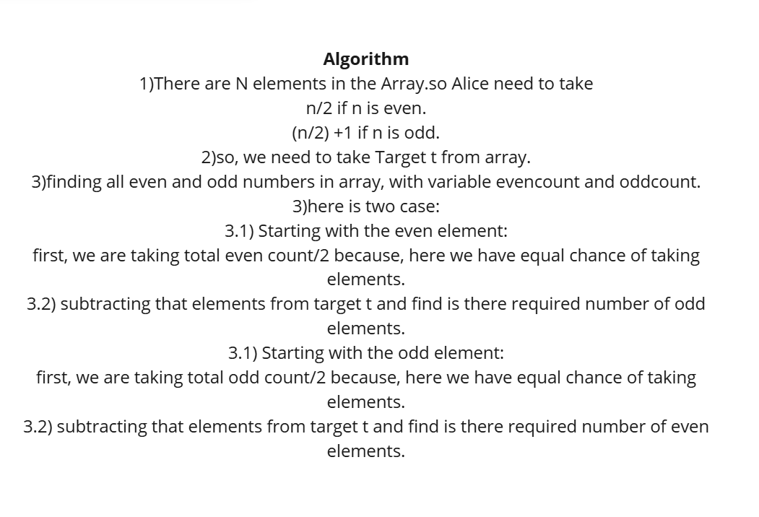

Given the of Size N with elements a1,a2,a3,a4,a5 .. an.

If the size of array is even, then alice need to take n/2

If the size of array is odd, then alice need to take (n/2)+1

Let target will be t=no.of slots to be filled by alice or no of elements alice need to take from array.

Now,in this we have even and odd numbers.

So, Initially iterate over the array and count the even and odd numbers in array

Stores in the evencount and oddcount.

There is two scenario:

1. Start with even numbers.
2. Start with odd numbers

Output will depend on both scenarios.

So,take a boolean flag with false.

Starting with even:

If we have more even numbers than required target ,we return true.

Removing all the even numbers from the required target and checking for the required number of odd are there or not.

If odd numbers are enough for the target then the flag will be true.

Else flag will be false.

Starting with odd:

If we have more odd numbers than required target ,we return true.

Removing all the even count of odd numbers from the required target and checking for the required number of even are there or not.

If even numbers are enough for the target then the flag will be true.

After checking both scenarios, if flag is true then we decide Alice is winner, else Bob is winner.